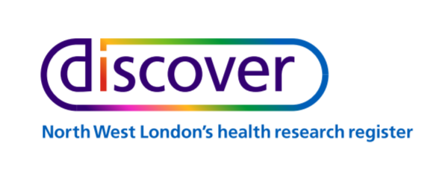

Discover Health Research Register
Data Access Guidelines
Discover can be used by approved health care researchers for assessing study feasibility, retrospective research and recruiting potential study participants. More information on the Discover Health Research register can be found at https://registerfordiscover.org.uk. This document provides information on the application and assessment process, detailing what is involved, the review criteria and the feedback and appeals process.

Application Process
To access the system potential users will need to register and submit a project request to the Discover Team through the following process:
- Download and Complete a Discover user registration form available online at https://registerfordiscover.org.uk/researchers.
- Download and complete the appropriate project application form (e.g. feasibility, retrospective, recruitment) available online at https://registerfordiscover.org.uk/researchers. The project type will determine the information required.
- Once both forms are completed submit these to enquiries@registerfordiscover.org.uk
- The Discover Team will review the application for completeness and communicate with the applicant expected timelines, progress and outcomes. If information is missing, the applicant will be asked to provide before further review takes place.
- The application will then be triaged for review based on the project type.
- Feasibility questions: The application will be reviewed by the Discover Team for completeness and to ensure it falls within the Discover Principles Charter. Decisions on applications are expected to take 5 working days.
- Cohort recruitment and Retrospective Studies: Will be sent to the Discover Research Access Group for review and a decision. Decisions on applications are expected to take up to 20 working days.
- The Discover team will confirm the quote for the research study. This quote will be made up of a licence fee for access to the data (where applicable) and the cost for any Discover days effort to support the research study.
- If approved, this will be communicated to the researcher by the Discover team along with the Data Access Agreement for signing.
- Following signatures on the agreement, access to the requested data will be provided or the study can commence.

Figure 1. Project Application Process
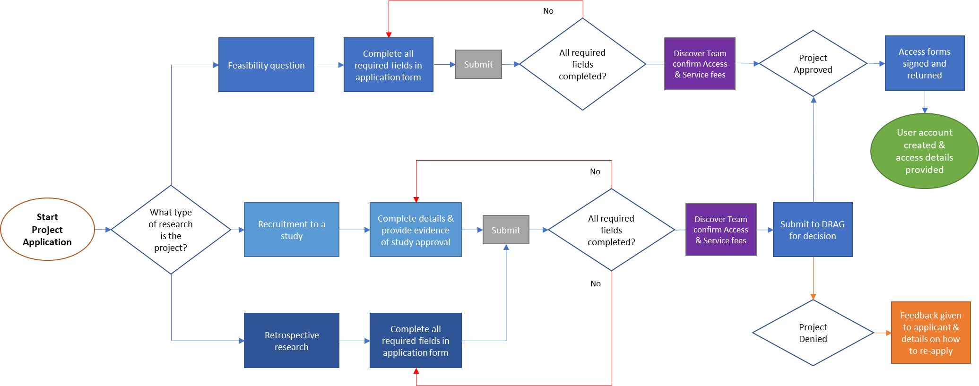

Discover Research Access Group (DRAG)
The DRAG is a nominated body that provides a governance mechanism for evaluating project applications (see example form in Appendix 1) requesting data from the Discover Platform. Access to Discover platform will be decided by the DRAG except for access to feasibility and anonymised reports.
The DRAG has responsibility for evaluating whether completed applications to access Discover are consistent with the Discover Principles Charter and the criteria laid out in this document, and that the requests do not pose undue risk to the individuals, communities or organisations to which they relate; this includes evaluation of risk of loss of privacy and assurance that appropriate protections of confidentiality and ethics review are in place.
The DRAG Terms of Reference (see Appendix 2) provides detailed information on the DRAG role, membership, duties and decision-making processes.

Eligibility

3.1 Eligibility of the Requestor
Discover is accessible to researchers (the ‘requestor’) with a remit including health, research or academic pursuit, and with legal status which includes scope to sign the Data Access Agreement. The Data Requestor will attest that sufficient funding and resources to perform the proposed research have been secured for this purpose. The DRAG will consider the potential impact of any conflicts of interest declared in the application. Applicants will not have previously violated any of the requirements of the Data Access Agreement.

3.2. Eligibility of the Research Proposal
Research proposals (project applications) must be scientifically sound with adequate methodology to answer the principle research question. Where possible it should address a knowledge gap of value or potential value to the scientific community, health and care sector, and/or to wider public health. The populations and requested data must be appropriate for the investigation.
The Discover Platform operates in line with the research priorities of the North West London health economy. Whilst applications that address issues within this agenda will be prioritised, applications to access Discover as part of research outside of these priorities will not be excluded and shall not be used as a basis to deny a proposal.

3.3. Eligibility of research ethics and other approvals
All research proposals, except feasibility questions and requests for access to anonymised reports, must be approved by a Trust or University R&D Department and when required (e.g. if recruitment is being sought) the Health Research Authority, along with any other approvals required for the Data Requestor to undertake the research.

Applications may be submitted prior to obtaining all necessary approvals and the DRAG shall be allowed to issue a letter of intent indicating approval of the application and making data access contingent upon receipt of the relevant approvals. Access to Discover will only be made available when all required approvals are in place. Data Requestors are responsible for ensuring that the rights, safety, privacy and welfare of the subjects are protected at all times, as outlined in the Data Access Agreement.

4. Feedback and Appeals

4.1 Feedback from the Discover Research Access Group (DRAG)
The decision of the DRAG will be communicated to the Data Requestor within 20 working days of application receipt. The DRAG may decide one of the following:

- Approve the access request;
- Approve the access request subject to minor amendments or caveats (these may be subsequently approved by the Chair if satisfied);
- Defer for further consideration (additional expertise may be co-opted to review, or further information may be solicited from data requestor);
- Reject the access request, with rationale provided.

The outcome will be communicated via the Discover Team and a hard copy will also be sent to the researcher, alongside the Data Access Agreement (see Appendix 3). Upon receipt of the signed agreement, a user account will be created for the requestor to access the relevant data or, access to an analyst who will provide the requested information. The response to Requestors whose applications do not meet the eligibility requirements, or which are judged to pose a risk of harm will include an explanation of the decision from the DRAG.

4.2 Rejected Applications/Appeals Process
Requestors who have had their project applications rejected may resubmit an application if amended with revisions which address the findings or feedback of the DRAG. If the DRAG rejects the application a second time, a final review can be requested from the Discover Steering Committee. The DRAG will advise applicants of the timeline for a final review and the decision of the Steering Committee will be final.

5. Document Revisions
Substantial revisions to the Data Access Guidelines must be agreed by the Discover Steering Committee and the DRAG.

Appendix 1: Application Review Checklist
- All sections of the application form that are mandatory have been completed.
- The applicant has formal affiliation to an institution with a remit including health, research or academic pursuit, and with legal status that includes scope to sign the Data Access Agreement.
- The applicant attests sufficient funding and resource are in place to carry out the project proposed.
- The applicant attests and provides evidence they are suitably qualified and trained to carry out the project proposed.
- Any conflicts of interest declared by the applicant have been reviewed.
- The applicant has the required approvals for their project in place and evidenced these in their application.
- The application is scientifically sound with adequate methodology to answer the principle research question.
- The application addresses a knowledge gap of value or potential value to the scientific community, health and care sector, and/or to wider public health.
- The populations and requested data is appropriate for the project.
- The publication/dissemination plan is appropriate for the project.
- The applicant acknowledges they have read the ‘Data Access Agreement’ and should their application be approved they will abide by its terms and understand their responsibilities as part of entering the agreement.
_______________________________________________________________________________

Appendix 2: DRAG Terms of Reference
[insert agreement]

Appendix 3: Data Access Agreement
[insert agreement]

